Malabar Black Pepper: The King of Spices from India – Bold Flavor, Global Legacy
Meta Description: Discover Malabar Black Pepper from The Export Express — India’s bold, aromatic, and antioxidant-rich spice exported worldwide for culinary and wellness excellence.

🌿 Introduction: The Legendary King of Spices
Among all spices that shaped global trade and cuisine, black pepper (Piper nigrum L.) stands as the undisputed king. Cultivated for centuries along India’s Malabar Coast, this aromatic treasure has seasoned empires, spurred exploration, and continues to dominate kitchens and wellness industries across the world.
At The Export Express, we bring you the finest Malabar Black Pepper – Light Berries, sourced from Kerala’s fertile plantations. Renowned for its sharp aroma, bold flavor, and uniform granules, our export-grade pepper represents India’s spice heritage and unmatched quality.

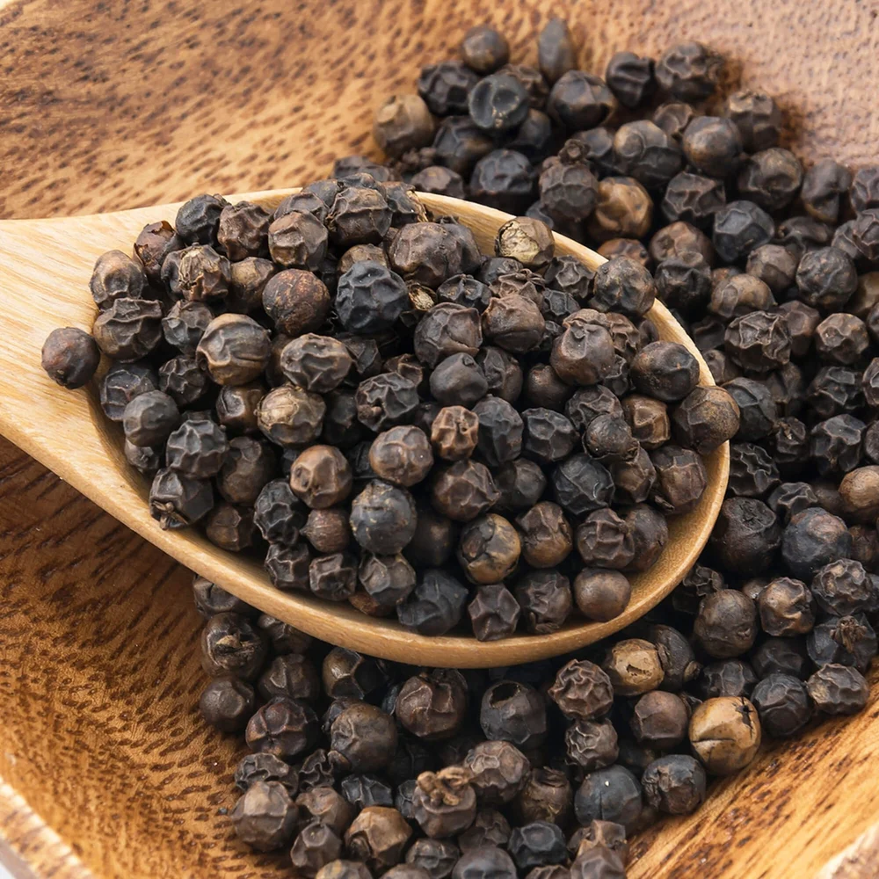
Caption: Malabar Black Pepper — India’s ancient spice legacy, handpicked and sun-dried to perfection.

🔬 Product Specifications
Parameter | Specification
Variety | Malabar Black Pepper
Grade | Light Berries (Export Quality)
Form | Whole Granules
Color | Deep Black
Is It Dried | Yes (Naturally Sun-Dried)
Pack Size | Loose / Customized Export Packs
Availability | In Stock
Origin | Kerala, India
Purity | 100% Natural
Shelf Life | 18–24 months (under dry storage)

🌱 The Origin: From Kerala’s Malabar Coast
The Malabar region of Kerala is the birthplace of pepper cultivation. Its humid tropical climate, fertile red soil, and monsoon rhythm create the ideal conditions for growing pepper vines that yield high-oil-content, aromatic berries.
Malabar Black Pepper is distinct for its uniform dark color, wrinkled skin, and dense core, contributing to both taste and nutritional strength.

🍴 Aromatic and Pungent Flavor
Whole black pepper berries from The Export Express offer:
- A strong, sharp, and woody aroma
- Pungent, earthy flavor with citrus undertones
- Long-lasting heat and complexity when freshly ground
This makes it an essential seasoning for Indian, Mediterranean, Middle Eastern, and European cuisines.

🧂 Culinary Applications

1. Everyday Cooking Essential
Use whole or crushed pepper to season curries, soups, salads, eggs, or roasted vegetables. Its natural oils intensify flavor when freshly ground.

2. Global Gourmet Recipes
- India: Black pepper rasam, masala chai, and spicy marinades
- Italy: Classic Cacio e Pepe pasta
- France: Peppercorn steak sauce (Steak au Poivre)
- Middle East: Pepper-infused rice and kebabs

3. Pickling & Preserving
Whole peppercorns add aromatic depth to brines, chutneys, and preserved meats.

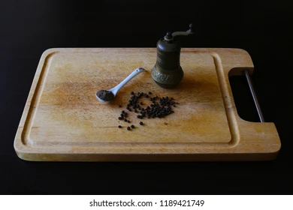
Caption: Freshly ground Malabar Black Pepper — unlocking its bold aroma and signature warmth.

💪 Health Benefits of Black Pepper

1. Rich in Antioxidants
Black pepper contains piperine, a powerful antioxidant that neutralizes free radicals and supports healthy aging.

2. Enhances Nutrient Absorption
Piperine increases the bioavailability of vitamins and minerals, improving the absorption of nutrients like curcumin from turmeric, selenium, and beta-carotene.

3. Supports Digestion
Black pepper stimulates the secretion of hydrochloric acid, promoting better digestion and nutrient breakdown.

4. Anti-Inflammatory & Detoxifying
Its natural anti-inflammatory properties help manage inflammation and support liver detoxification.

5. Respiratory and Immune Health
Black pepper’s warming quality helps relieve coughs, congestion, and boosts immune resilience — a reason it’s used in Ayurvedic kadha and herbal tonics.

🌿 Ayurvedic Perspective
In Ayurveda, black pepper (Maricha) is considered a tridoshic spice — balancing Vata, Pitta, and Kapha when used moderately.
It’s one of the three ingredients in Trikatu (along with long pepper and dry ginger), a potent blend used for digestion, metabolism, and detoxification.
Traditional Ayurvedic Uses:
- Stimulates digestive fire (Agni)
- Clears respiratory channels
- Improves circulation and energy
- Enhances the efficacy of other herbs (bioenhancer property)

📊 Nutritional Composition (per 100g)
Nutrient | Value
Energy | 255 kcal
Carbohydrates | 64 g
Protein | 11 g
Fat | 3 g
Fiber | 25 g
Calcium | 440 mg
Iron | 10 mg
Piperine | 3–5% (varies by grade)

🏭 Why Choose The Export Express for Malabar Black Pepper?

Premium Sourcing
Handpicked from Kerala’s certified pepper plantations with traditional drying methods that retain oil and aroma.

Stringent Quality Control
Every batch undergoes moisture, piperine content, and microbial testing to meet export and FSSAI standards.

Sustainable & Ethical Trade
Our farmers practice organic, eco-friendly cultivation with traceable sourcing.

Custom Packaging for Export
Available in bulk sacks (25–50 kg) or retail-ready pouches with private labeling options.

📦 Packaging Options
Packaging Type | Weight | Material
Jute Bags | 25 kg / 50 kg | Eco-friendly, breathable
Poly-lined Bags | 10 kg / 25 kg | Moisture-resistant
Pouches | 100 g / 500 g / 1 kg | Retail export packaging
Vacuum Sealed | 10 kg | Long-term freshness preservation

Conclusion: A Global Spice with Indian Soul
From ancient spice routes to modern kitchens, Malabar Black Pepper continues to reign supreme — celebrated for its rich aroma, medicinal strength, and timeless flavor.
At The Export Express, we ensure every peppercorn embodies India’s commitment to quality, sustainability, and authenticity. Whether for culinary use or wholesale export, our Malabar Black Pepper Light Berries deliver the essence of India’s most prized spice — bold, pure, and aromatic.

Keywords: Black pepper exporter India, Malabar black pepper, herbal export India, Indian spices export, whole black pepper granules, black pepper supplier.

